

**“Mixed Local Produce Bag Initiative”**

**Partnership with Guam State Office on Aging and Guam Farmers’ Cooperative Association of Guam with the University of Guam’s Cooperative Extension & Outreach** - August 8, 2020

**Guam’s State Office on Aging, Mixed Local Produce Bag Initiative** dialogue started in June 2020 while searching for *Out of the Box ideas* to provide our seniors who are at home with other nutrition options. The Guam Farmer’s Co-Op began selling $25 bag of local vegetable and fruits and we then connected with the local University, which provides Cooperative Extension for the Farmers as they also serve as advisors to the farmers in promoting local produce with the hotels, restaurants and supermarkets and village stores. Since the hotels have minimal guests the University is assisting the Co-op with other markets for their produce which today includes Aging for our Congregate Home-Based and Drive Thru and Home-Delivered Meals for our seniors; school Drive Thru, Corrections Department and local hospitals.

Our main aim from Aging was to provide fresh vegetable and fruit for the seniors and/or caregivers to enhance their daily meals and support local farmers who are impacted, as the hotel industry which is one Guam’s top industry for revenue has significantly declined. Guam does have local legislation on Buying local. Through the local university we shared our menus and have since provided our Nutrition Vendor an introduction to the Guam Co-op as a potential market for vegetable and fruits for menu planning.

The **Mixed Local Produce Bag Initiative** is a *Win* for the seniors and caregivers by providing local vegetable and fruit. A *Win* for the Farmer’s Cooperative as Aging stepped up to be part of their market. A *Win* for the University for bringing forth their community action initiatives so we can promote services for our aging clients and caregivers.

* From L. Robert Baber, Jr.: ***This mixed produce bags for seniors is a shining example of this effort. We are committed to providing our professional support to making this project work.*** Professor/Extension Specialist, Agriculture Economics and Sustainable Agriculture, Graduate Chair, Sustainable Agriculture Food and Natural Resource Program UOG/CNAS- July 31, 2020

Funding for the *Mixed Local Produce Bag Initiative* is through the CARE Act Nutrition. The *Mixed Local Bags* will be distributed to the Southern, Central, and Northern in coordination with our Aging partners from the Senior Centers, Transportation, Adult Day Care and for homebound we will be coordinating with Nutrition Vendor for delivery, Case Management and In-Home which are key, as they are boots on the ground.

**Guam State Office on Aging ⧫ Acting Senior Citizens Administrator Charlene D. San Nicolas, MPA**

**Attachment 1- Buy Guam Grown Seasonality Chart**

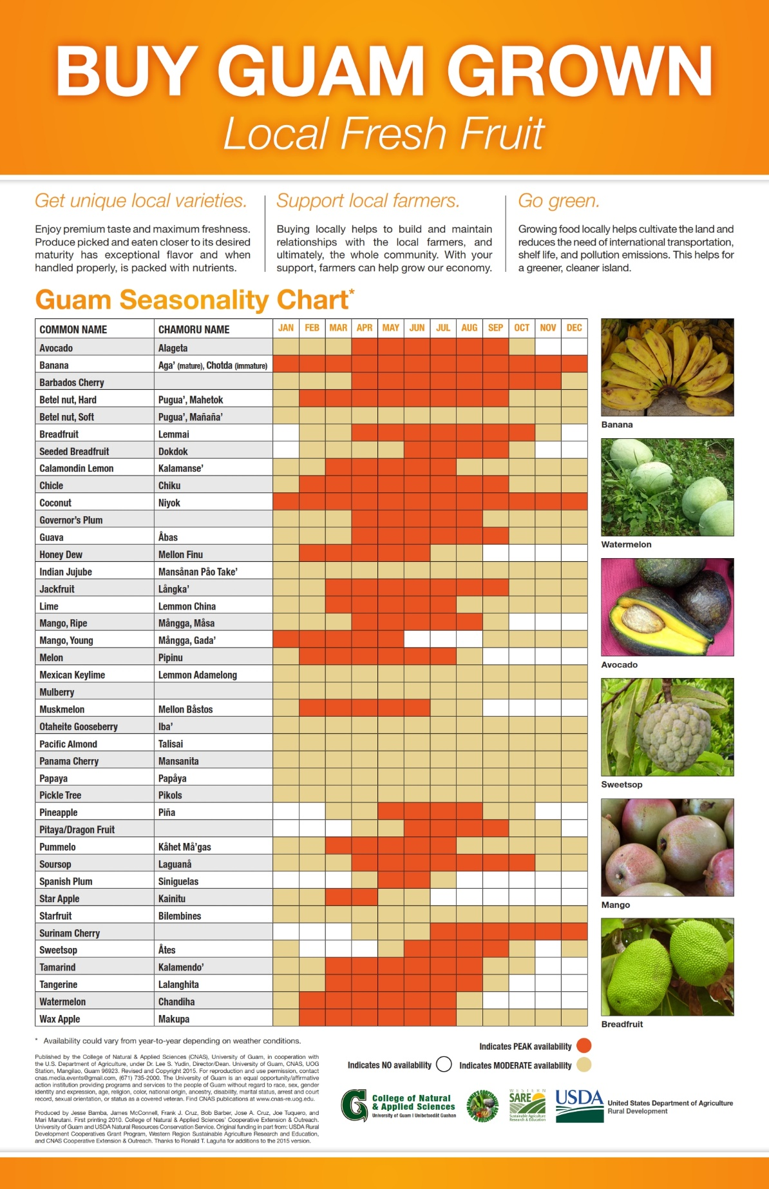

**Attachment 2- Guam Mixed Local Produce Bag $8 Local Bag Sample**

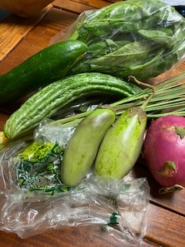**Vegetables:** Cucumber, local Eggplant, Lemongrass, Water Spinach (Kangkong),

**Fruit:** Dragon fruit

**Attachment 3- Guam Farmer’s Co-Op Flyer $25 Fruit/Vegetable**

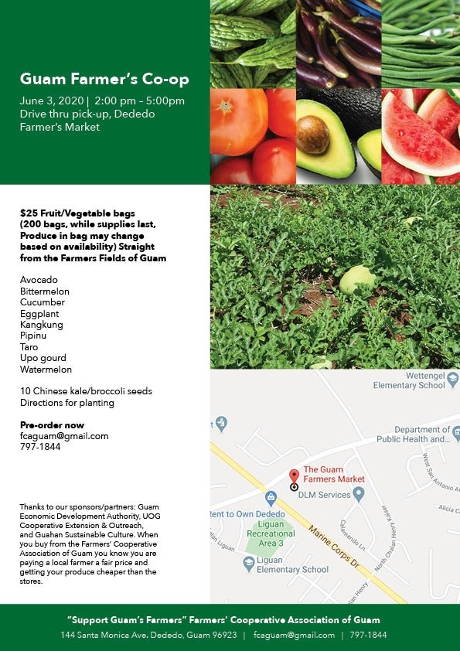Challenges: Logistical for Islandwide delivery and cost with availability.